|  |
| --- |
| 新东方在线英语学习 |
| 新概念 2 册 |
| Lesson15 |



扫一扫。更多有趣的英语资讯。

# Lesson 15 单词讲解

1. secretary n. 秘书

secret n. 秘密

1. nervous adj. 精神紧张的

feel nervous be nervous

nerve n. 神经

1. afford v. 负担得起

can / could / be able to + afford + sth. / to do sth. Students cannot afford the books.

Nowadays people can afford to travel abroad.

1. interrupt v. 插话，打断

Don’t interrupt! inter-

internet n.

interview v. / n. international adj. interaction n.

# Lesson 15 课文&语法讲解

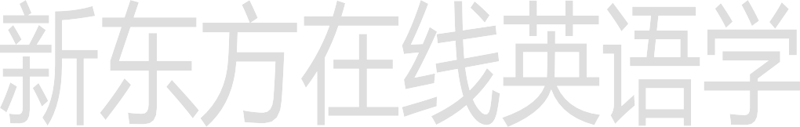

Key points:

直接引语变间接引语

（宾语从句）

Review:

L7 陈述句 变 宾语从句

I believe (that) you can make it. 他说：“我是笨蛋。”直接引语他说我是笨蛋。

他说他是笨蛋。间接引语

He says, “I am a fool.” 直接引语

He says 间接引语

直接引语 变 间接引语 (宾语从句) He says, “I am a fool.”

He says (that) he is a fool.

He said, “I am a fool.”

He said (that) he was a fool.

直接引语 变 间接引语 (宾语从句) He said, “I will go to Italy.”

He said (that) he would go to Italy. He said, “I went to Italy.”

He said (that) he had gone to Italy.

直接引语 变 间接引语 (宾语从句) “Business is very bad.”

He said .

直接引语 变 间接引语 (宾语从句)

“Mr. H will see you.”

The secretary told me .

直接引语 变 间接引语 (宾语从句)

“You will receive a thousand pounds.”

He told me .

1. The secretary told me that Mr. … would see me.
2. After I had sat down, he said that business was … bad.
3. He told me that the firm could not afford to pay …
4. I knew that my turn had come.
5. Then he smiled and (he) told me (that) I would receive …
6. The secretary told me that Mr. … would see me.
7. After I had sat down, he said that business was … bad.
8. He told me that the firm could not afford to pay …
9. I knew that my turn had come.
10. Then he smiled and told me (that) I would receive …

# Lesson 15 知识拓展

高考新题型 单词拼写

More and more Chinese people are able to afford (负得起) to travel abroad. more and more people

= an increasing number of people (2012 陕西)

Will you stop (打断) me when I’m talking? stop doing sth.

stop to do sth. (2012 全国)

陈述句 变 宾语从句

You are right.

I think .

我相信我能飞。

I believe (that) I can fly.

他知道我们将去拜访他。（过去）

He knew that we would go and visit him.

我希望你尽快好起来。

I hope that you will be better soon. Tony 意识到他应该更努力的学习。

Tony realizes that he should study / work harder.

我梦到我在你家。（过去）

I dreamed that I was at your house.

老师们总告诉我们我们必须按时完成作业。

Teacher always tell us that we must finish the homework in time.

每个人都知道地球绕着太阳旋转。

Everyone knows that the earth travels / revolves around the sun.

哦，我忘记告诉你了，昨天有个电话找你。

Oh, I forgot to tell you that there was a phone call for you yesterday.

